How to submit your work Via Google Classroom
- Open the Google Classroom link you have accepted the invitation to, and click the heading ‘classwork’

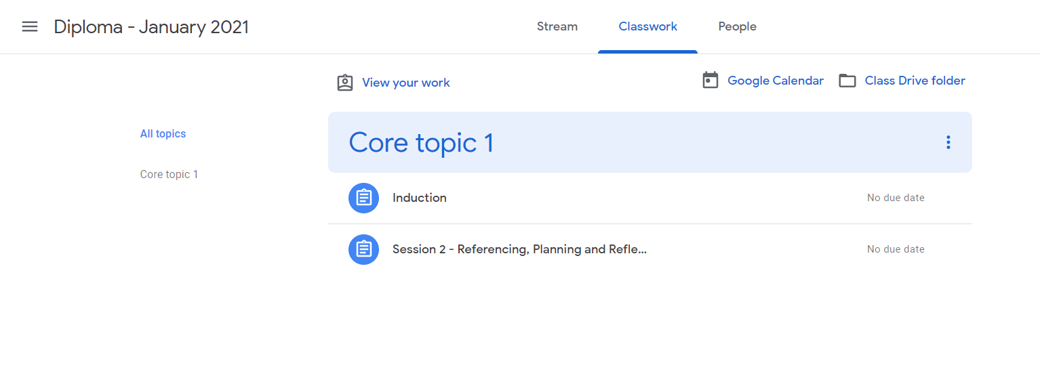

- You should then be able to see your topics. Click on the topic you wish to send work under, in this case ‘session 2’. You should then see a view assignment tab at the bottom of the box, like this. Click ‘view assignment’.

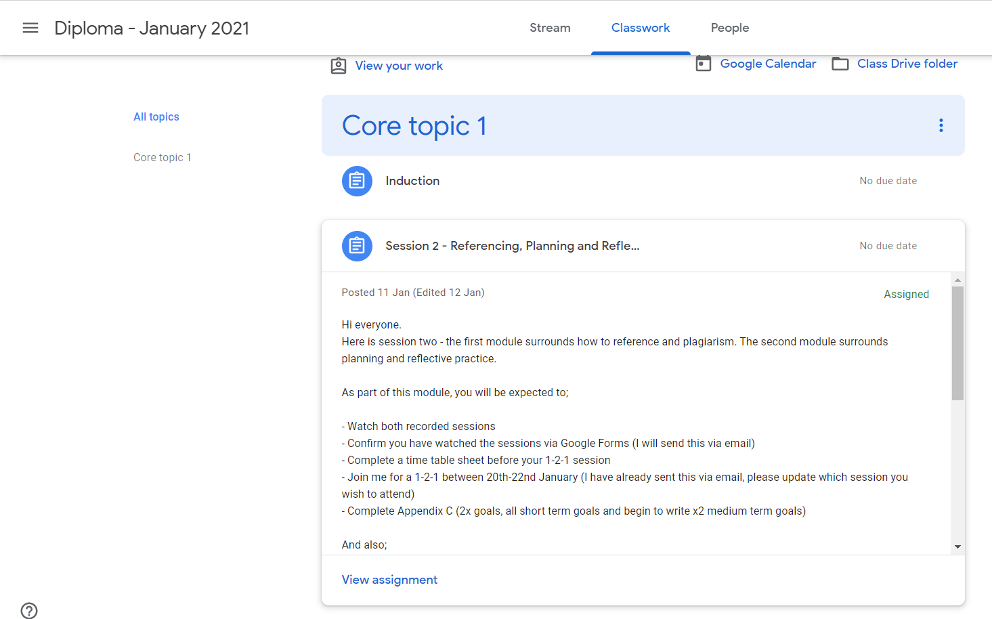

- After clicking ‘view assignment’, you should be able to see something like this. Here, you will find the instructions of the assignment, and all of the sources and documents needed for that assignment. To upload any work you have created on a word document OR to create a google docs sheet for you to complete your work on, you need to click ‘add or create’ to the right hand side of the page.

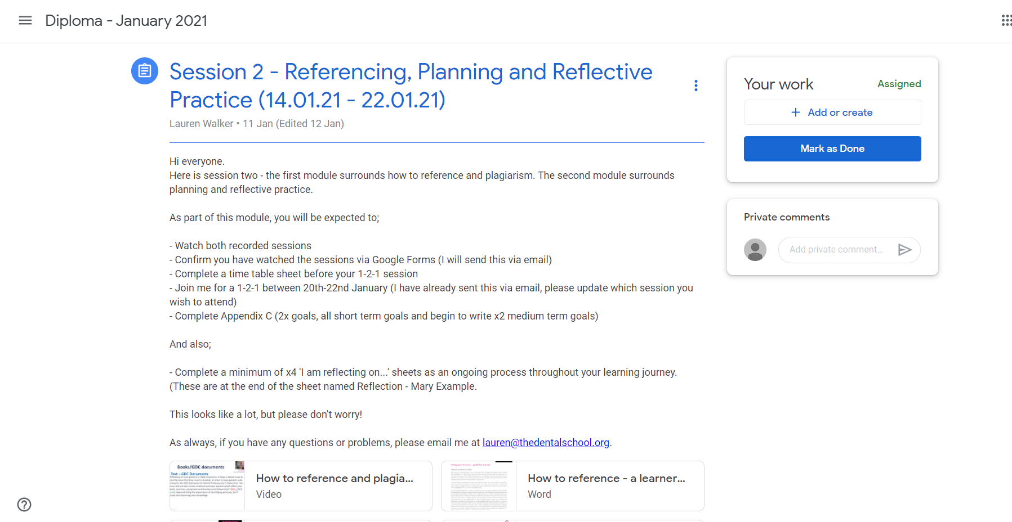

- After clicking the ‘add or create’ button, this will appear. To add a word document, just click ‘file’. To create a submission on a word type document, click ‘docs’.

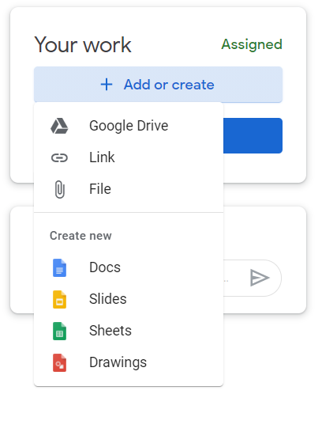

Now you should be able to either upload a file, or create your first piece of work!

