How to download and save work to your PC
- Open your Google Classroom link, and click onto the session you wish to download work from. In this case, I have chosen ‘Session 2’.
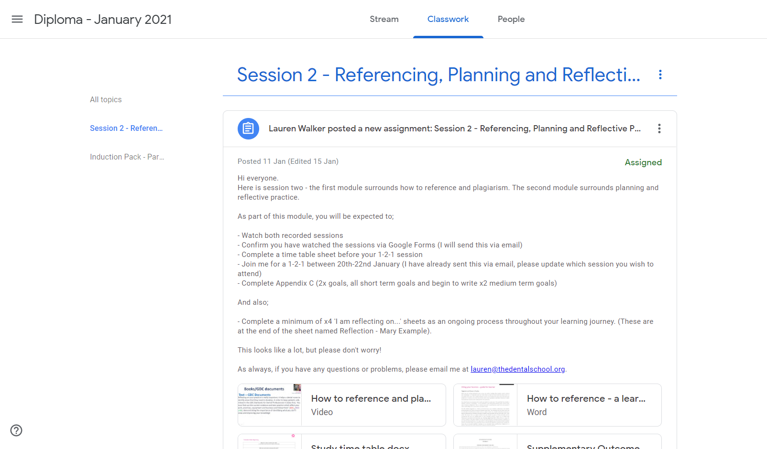
- Scroll down and find the pieces of work that you wish to download to edit. In this case, I have chosen ‘study timetable’ to open and download.
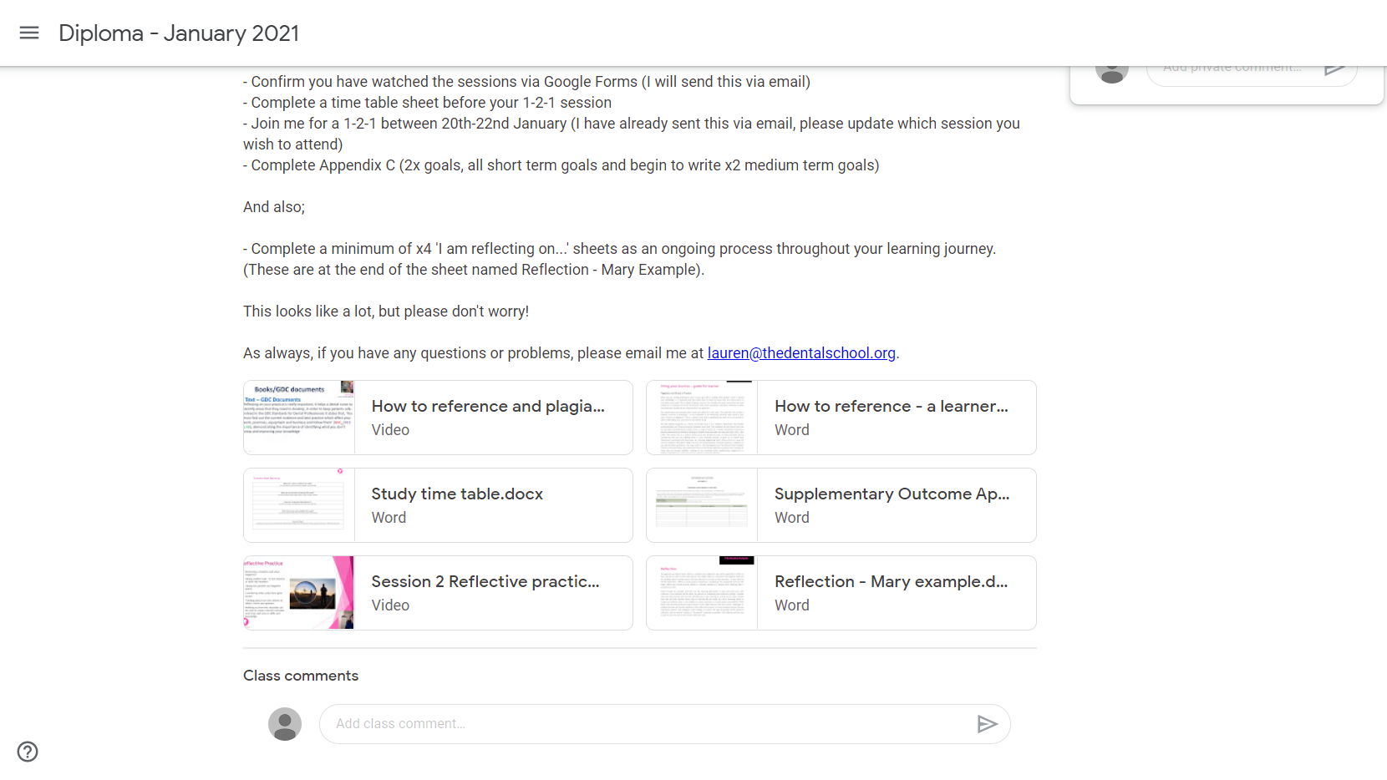

- Once clicking on the ‘study timetable’, this google doc should open as a template. PLEASE NOTE: you cannot edit this document on this screen, it basically acts as a image for you to see what is inside of the document. In order for you to be able to download this document to edit, please click on the ‘OPEN WITH GOOGLE DOCS’ tab at the top of the page.

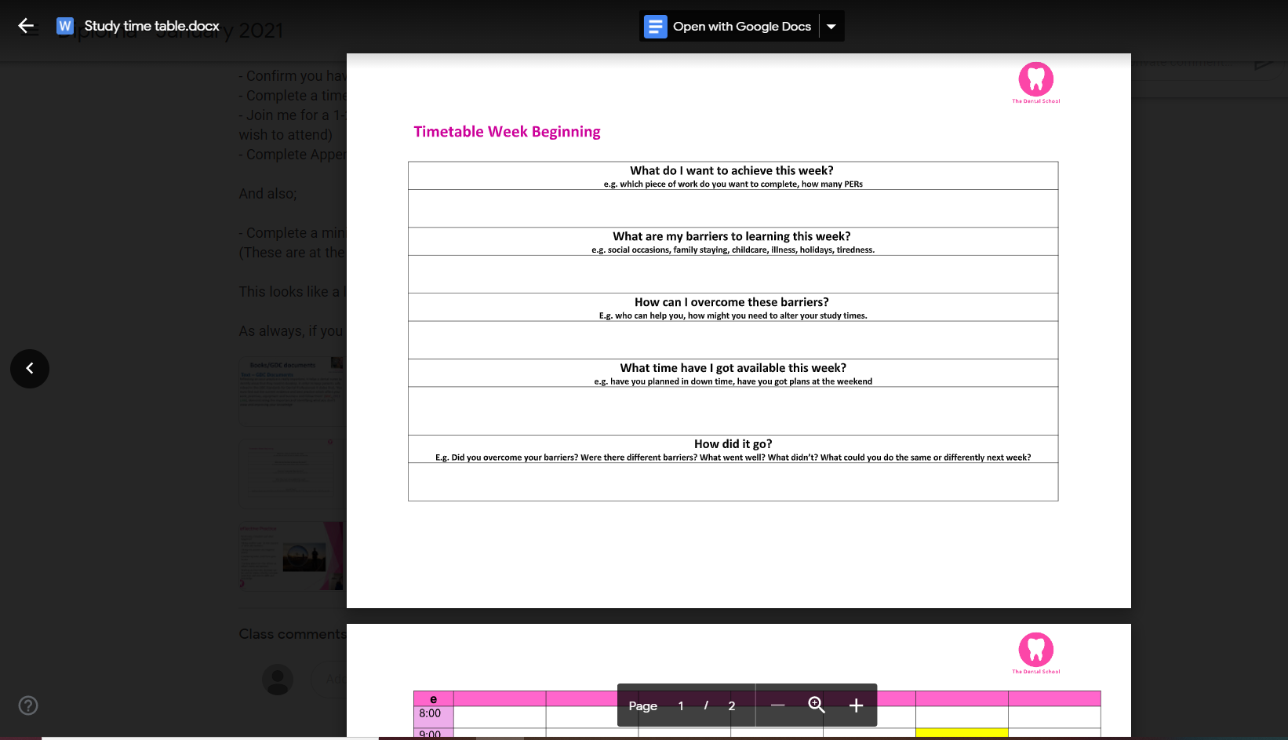
- Once you click on the tab, this page should appear. You can edit this page, however, I suggest you download a copy to upload at a later date.
To download a copy, simply click ‘file’ in the top left corner, then scroll down to ‘download’ and across to ‘Microsoft word’. This will then download a copy for you to be able to save onto your PC/laptop, for you to edit.

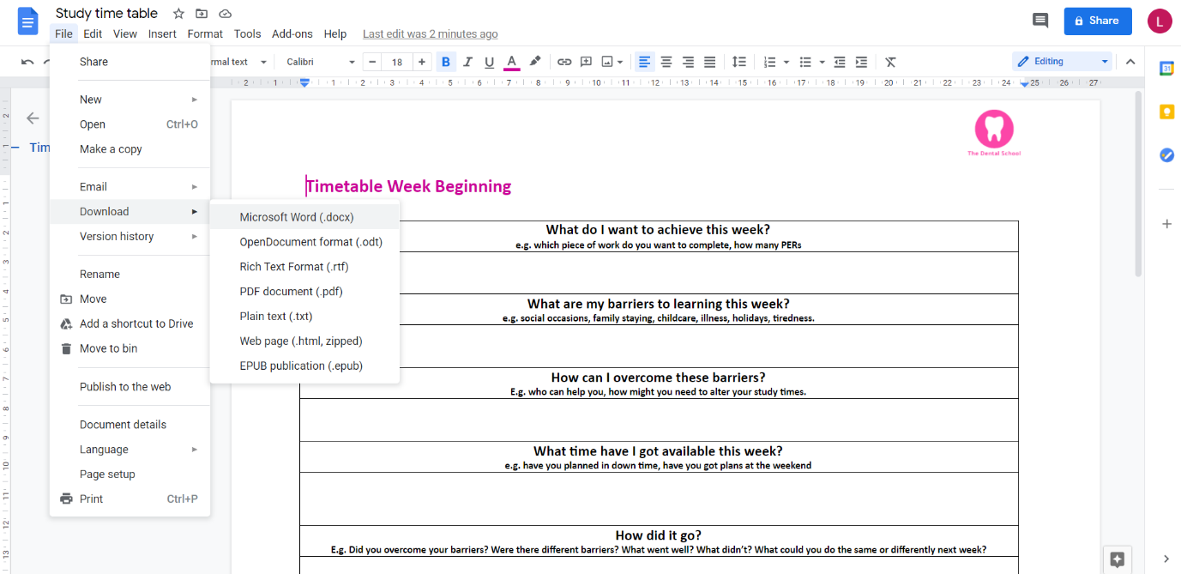
- Once you have pressed download, and pressed Microsoft Word, on the bottom left hand side you should see the downloaded document, and an ‘open file’ tab highlighted in blue. Click ‘open file’.
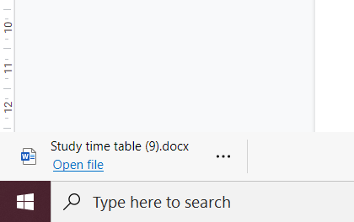
- Then, the file you can save/edit should be visible on your computer! PLEASE NOTE: Sometimes these documents are in ‘protected view’. To enable you to edit these documents, you need to click the box at the top labelled ‘enable editing’. You should then be able to edit and save your documents straight onto your desktop.
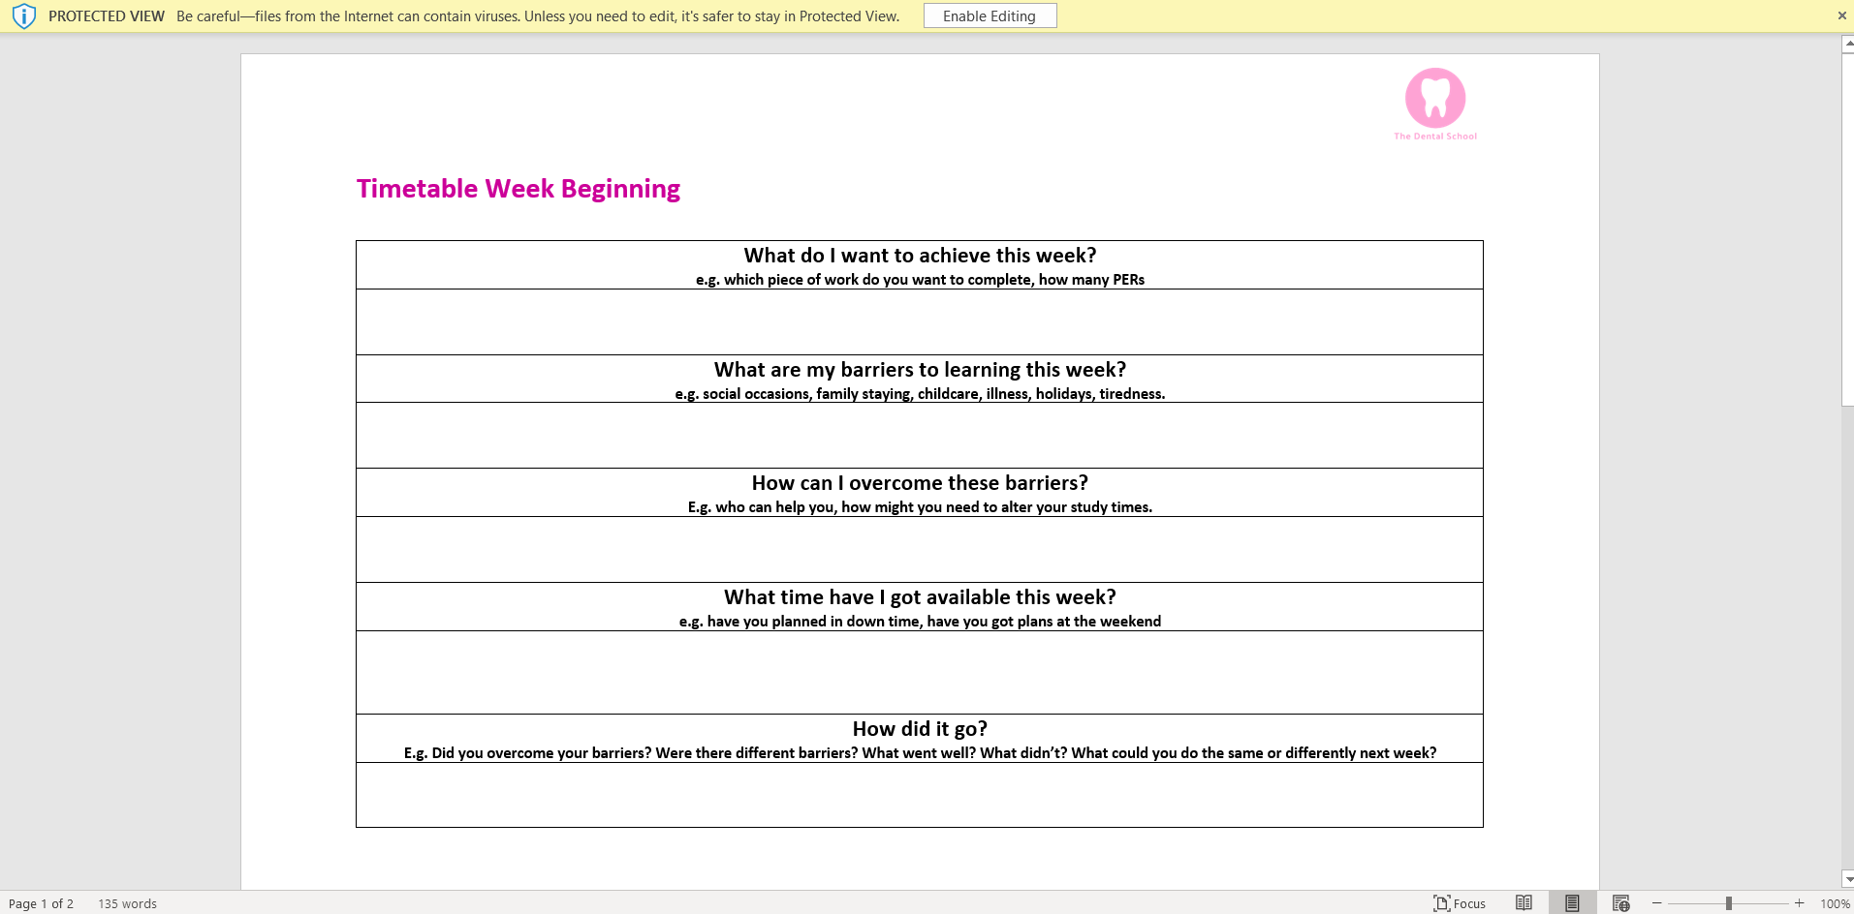
- To know learn how to upload these documents on the Google Classroom platform, please see my ‘How to submit work (Google Classroom)’ document.

